**Application of Street View Semantic Segmentation and Multiple Regression in Assessing Urban Thermal Environment:**

**A Case Study of City Blocks in Westminster**

By jiabo Zhu

Date:

A dissertation submitted in part requirement

For the degree of

Msc Urban spatial science

Centre for Advanced Spatial Analysis

University College of London

Module ID:

Student ID:

Supervisor:

Word count:

**Contents**

Abstract

Declaration

Lists of tables

Lists of figures

Lists of files

Chapter 1: Introduction

1.1 Background of the Study

1.2 Research Questions

1.3 Objectives of the Study

Chapter 2: Literature Review

2.1 Previous Studies Related to Topic

2.2 Identification of Gaps in Existing Research

2.3 Justification for Study

2.4 Conceptual Framework

Chapter 3: Methodology

3.1 Research Design

3.2 Sampling and Sample Size

3.3 Data Collection Instruments and Procedures

3.4 Data Analysis Methods

Chapter 4: Results and Discussion

4.1 Presentation of Data

4.2 Analysis of Data

4.3 Interpretation of Findings

Chapter 5: Conclusion

5.1 Summary of Findings

5.2 Relationship to Existing Literature

5.3 Implications

5.4 Recommendations for Future Research

Bibliography

Abstract

Declaration

Lists of tables

Lists of figures

figure1: London average Land Surface Temperature (2016-2020)

figure2: London standard deviation of the average Land Surface Temperature (LST) (2016-2020)

figure3: Land surface temperature map of the study area (2016-2020)

figure4:

figure5:

figure6:

Lists of files

<https://github.com/jiabo0828/Anna_Thesis_semantic>

|  |  |  |
| --- | --- | --- |
| **1** | **Filename:** | avgLST_London_UrbanAtlas.gpkg |
| **Filetype:** | Geopackage(polygons) |
| **Description:** | The Urban Atlas polygons corresponding to the London core  area. Their attributes have been updated with the derived LST data (in  °C). |
| **Map proj.:** | OSGB 1936 / British National Grid – Projected - EPSG:27700 |
| **Data source:** | <https://data.london.gov.uk/dataset/major-summer-heatspots-using-landsat-8-thermal-satellite-data> |

|  |  |  |
| --- | --- | --- |
| **2** | **Filename:** | Landsat-8ThermalSatellitedata.csv |
| **Filetype:** | CSV |
| **Description:** | The dataset is a CSV file derived from a GeoPackage (GPKG) that represents the average surface temperatures for London from the years 2016 to 2020. It consists of 15 columns, among which only 10 are operationally relevant or hold significant data.  1. avgLST: 2016-2020 average,summer time, daytime LST  2. std_avgLST: the avgLST standard deviation for each city block  3. min_avgLST: the avgLST minimum for each city block  4. max_avgLST: the avgLST maximum for each city block |

|  |  |  |
| --- | --- | --- |
| **3** | **Filename:** | joined_data.csv |
| **Filetype:** | CSV |
| **Description:** | The table represents the combined information obtained by aligning and integrating the data from file 6 and file 2, following the transformation of coordinates to the WGS84 standard. The integration involved associating the point coordinates in file 6 with their corresponding block coordinates in file 2, enabling a comprehensive merged dataset. |
|  | **Data source:** | Google street view / <https://data.london.gov.uk/dataset/major-summer-heatspots-using-landsat-8-thermal-satellite-data> |

|  |  |  |
| --- | --- | --- |
| **4** | **Filename:** | Map.osm |
| **Filetype:** | OSM |
| **Description:** | Map corresponding to the analysed area. |
|  | **Data source:** | <https://www.openstreetmap.org/#map=15/51.4960/-0.1326> |

|  |  |  |
| --- | --- | --- |
| **5** | **Filename:** | ade20k_lables.xlsx |
| **Filetype:** | txt |
| **Description:** | This code corresponds to the corresponding column name in Interpretation File 6. |
|  | **Data source:** | Github/CSDN |

|  |  |  |
| --- | --- | --- |
| **6** | **Filename:** | all_merge.csv |
| **Filetype:** | CSV |
| **Description:** | Data with 150 columns of correlation values obtained by semantically analysing Google Panorama photos(File7) of corresponding points in Street View, which include sky, trees, rivers, roads, cars, etc. |
|  | **Data source:** | Google street view |

|  |  |  |
| --- | --- | --- |
| **7** | **Filename:** | Picture.zip |
| **Filetype:** | zip |
| **Description:** | Google panoramic photographs of the study area collected at 10m separation points, a total of 15,931 photos. |
|  | **Data source:** | Google street view |

|  |  |  |
| --- | --- | --- |
| **8** | **Filename:** | StreetSemanticSegmentationResults.zip |
| **Filetype:** | zip |
| **Description:** | Results of Street View Semantic Analysis for Google Street Panoramas, a total of 15,931 photos. |
|  | **Data source:** | python |

|  |  |  |
| --- | --- | --- |
| **9** | **Filename:** | greenratemap.mxd |
| **Filetype:** | Arcgis |
| **Description:** | Results of Street View Semantic Analysis for Google Street Panoramas, a total of 15,931 photos. |
|  | **Data source:** | Arcgis |

|  |  |  |
| --- | --- | --- |
| **10** | **Filename:** | semanticpy.zip |
| **Filetype:** | zip |
| **Description:** | Street View Semantic Analysis Package |
|  | **Data source:** | python |

Chapter 1: Introduction

**1.1 Background of the Study**

Urban environments continue to evolve as global urbanization rapidly progresses. One of the major environmental challenges associated with this urban growth is the Urban Heat Island (UHI) phenomenon, where urban regions experience significantly higher temperatures compared to their rural counterparts. This difference in temperature can impact human comfort, health, energy consumption, and even increase emission levels of pollutants and greenhouse gases. As such, understanding the factors contributing to the UHI effect and developing strategies to mitigate it is becoming increasingly vital.

Situated within this context, this research project aims to investigate the urban thermal environment in Westminster, utilizing a novel approach: the application of street view semantic segmentation and multiple regression analysis. This method aims to identify and quantify the proportion of different land cover types - such as buildings, roads, vegetation, and bodies of water - and evaluate their relationship with the local thermal conditions, also visualize the factors of the built environment of the area.

Semantic segmentation, a technique in computer vision, allows the categorization of each pixel in an image based on its semantic meaning, enabling precise spatial analysis of urban landscapes. Multiple regression analysis, a statistical technique, helps explore the relationship between these land cover types (independent variables) and the thermal environment (dependent variable), identifying which factors significantly contribute to the district's thermal conditions.

**1.2 Research Questions**

The importance of such a study is multi-fold, leading us to the primary research question: How does the proportion of different land cover types influence the urban thermal environment in Westminster? In pursuit of this question, this research aims to achieve the following objectives:

1. To identify and quantify the proportion of different land cover types in Westminster using semantic segmentation.
2. To analyze the relationship between these land cover types and the local thermal conditions through multiple regression analysis.
3. To assess which land cover types have a significant impact on the thermal conditions of the region, while visualizing the spatial distribution of this element.
4. To propose evidence-based urban planning strategies for mitigating UHI effects and promoting sustainable development.

**1.3 Objectives of the Study**

These objectives not only offer detailed insights into how urban design and planning can directly influence urban thermal comfort but also guide urban planning strategies and contribute to the current body of knowledge. By pursuing this study, we aim to enhance our understanding of urban thermal environments in rapidly urbanizing regions globally.

As urbanization continues, studies like these can play a crucial role in shaping our cities and towns. This research, through its novel methodological approach and commitment to urban sustainability, intends to make a substantial contribution to the field. The subsequent sections of this dissertation will discuss in detail the study area and data collection methods, the process of semantic segmentation and multiple regression analysis, the findings and interpretations of the study, and the implications of these findings for urban design and planning.

Chapter 2: Literature Review

**2.1 Previous Studies Related to Topic**

The phenomenon of Urban Heat Islands (UHIs) has been recognized for centuries, with one of the first notable observations made by Luke Howard in 1833. He reported a persistent thermal difference between urban and rural areas, highlighting that urban development significantly influences local climates. This early recognition has served as a foundation for numerous subsequent studies exploring this phenomenon and its implications on urban thermal environment.(Howard 1833) The Urban Heat Island (UHI) phenomenon, serving as a tangible measure of the influence of urbanization on cities' thermal environment, is manifesting with increasing concern in London, where it has been found to elevate temperatures by up to 10 degrees Celsius compared to adjacent rural locales.(2006) Should the prevailing trend of urbanization endure, the implications for London's urban population could be severe, most notably with respect to energy consumption and health ramifications, a concern that is particularly acute during the summer months. **什么是城市热岛效应，以及伦敦的城市热岛效应有多么严重**

The complexity of the UHI effect in London presents a multifaceted challenge. It not only heightens the demand for energy for cooling purposes but also catalyzes the creation of urban smog and contributes to thermal discomfort.(Rosenfeld et al. 1995) Beyond these immediate effects, the UHI phenomenon is also associated with adverse health outcomes, with the economically and politically marginalized being disproportionately affected.(He et al. 2021) **伦敦热岛效应带来的影响**

In this intricate context, an investigation into the UHI effect in Westminster, London, takes on critical importance. Characterized by both an elevated rate of building development and a significant human concentration, Westminster represents a microcosm of urban thermal dynamics that may yield insights with broader applicability. The exploration of this specific area, therefore, holds potential relevance not only to understanding the phenomena within Westminster but also for informing future research directions in the outdoor thermal environment, urban planning, and urban regeneration. **我为什么要对Westminster做分析**

Liyue Zeng undertakes a comprehensive examination of sky element analyses within four densely populated urban areas.(Zeng et al. 2018) Utilizing a methodological approach that integrates semantic segmentation, Zeng applies this technique to an extensive collection of streetscape images. These images are obtained through carefully selected sampling points situated along the urban road network, thereby allowing for an estimation of Sky View Factor (SVF) data. The analysis extends to a subsequent evaluation of critical urban spatial metrics, encompassing aspects such as radiation and the broader thermal environment. This research represents a sophisticated application of image analysis techniques to uncover intricate relationships within urban spatial configurations, contributing nuanced insights to the field of urban environmental study. **别人对uhi和街景是怎么研究的1**

Feng Yang embarked on a nuanced exploration of summer urban heat island (UHI) patterns within three high-rise residential neighborhoods located in central Shanghai.(Yang, Lau & Qian 2010) Their research involved a comparative analysis of UHI phenomena during both daytime and nighttime periods across the experimental sites. Through the employment of regression analyses, they rigorously tested the effects of specific site design variables on the intensity of the heat island effect. The independent variables selected for this study were Sky View Factor (SVF), Green Plot Ratio (GPR), Green Cover (GCR), and Tree View Factor (TVF). These variables were meticulously regressed against UHI, serving as the dependent variable, to derive the results. Based on the outcomes of this robust statistical analysis, the authors proceeded to articulate the design implications of their findings, emphasizing the need to consider other salient factors in the design and planning of urban environments. This scholarly investigation contributes to a deeper understanding of the urban heat island effect, elucidating how complex interactions between various environmental variables can influence urban thermal dynamics. **别人对uhi和街景是怎么研究的2**

Umberto Berardi conducted a rigorous investigation into potential strategies to alleviate the adverse effects of heat waves in the urbanized context of the Toronto region.(Berardi, Jandaghian & Graham 2020) Utilizing two distinct yet complementary models, namely the Weather Research and Forecasting Model (WRFM) for mesoscale simulations and the ENVI-met model for microscale simulations, the study embarked on an in-depth examination of the effects of augmented greening. The methodological framework of this research permitted a sophisticated analysis of how increased vegetation might function as a mitigation strategy. Through careful analysis, the authors arrived at a robust set of findings, affirming that the enhancement of urban greenery stands as an effective method to reduce ambient temperatures. Furthermore, the results illuminate the potential for such a strategy to contribute to an improved quality of urban living for residents. This research adds valuable insights to the existing body of knowledge surrounding urban climate adaptation and mitigation, and specifically underscores the utility of vegetative interventions in moderating thermal conditions. **别人对uhi和街景是怎么研究的3**

In the context of urban environment evaluation, the utilization of Google Street Map has recently emerged as an indispensable methodological innovation. Its broad global coverage and detailed street-level imagery offer a unique window into the complexities of urban landscapes. With horizontal angles approaching 360 degrees and vertical angles nearing 180 degrees, the imagery captures an extensive array of information, inclusive of both the static features of the built environment and the dynamic components such as pedestrian and vehicular activity. Furthermore, the accessibility of over 20,000 real-life photos per day via a personal API underscores Google Street Map's practicality as a substantial data source. This breadth and accessibility pave the way for innovative research strategies and provide a diverse sample from which nuanced insights can be drawn. Moreover, the associated low costs of data collection enhance its appeal to a wide array of research endeavors. The integration of Google Street Map into urban spatial analysis represents a significant advancement in the field, allowing for a more comprehensive and multidimensional understanding of urban spaces.(Carrasco-Hernandez, Smedley & Webb 2015) Its wide-ranging applications, encompassing the granular details of individual locations to broader street-level vistas, present a novel perspective that contributes to the richness of the urban environment study. **使用谷歌街景地图和semantic的必要性**

Urban infrastructures often use materials that effectively store short-wave radiation and release heat. Various urban surface factors - material, specific heat capacity, density, and specific emissivity - differ in their abilities to absorb solar radiation and release heat, and these contribute differently to the thermal environment of a city(Figure1) The land surface temperature (LST) of each surface factor can be recorded using remote sensing technology, aiding in the study of the contribution of various surface factors to the urban thermal environment.(Jusuf & Hien 2007) **LST指标的使用**

The changing urban landscape causes changes to the biophysical environment, including the spatiotemporal pattern of the LST. Land surface characteristics, primarily represented by land cover and land use (LCLU), have been a focus in numerous studies on the urban thermal environment. However, establishing the actual relationship between urban thermal characteristics and surface factors remains challenging due to the complexity of thermal remote sensing and the heterogeneity of urban surface thermal properties. Recent years have seen an intensification in research efforts in this field. A significant focus has been on vegetation information and the interrelationships between vegetation and the thermal environment.

In the context of the United Kingdom, the escalating frequency of heatwaves has been identified as a factor contributing to an elevated risk of mortality among vulnerable populations. This concerning trend necessitates a rigorous examination of the urban heat island (UHI) effect, particularly its spatial distribution and the influence exerted by the built environment.(Taylor et al. 2015) By engaging in systematic analysis and calculation of these factors, urban planners and designers are equipped to incorporate strategies that mitigate these risks within their planning processes. This entails not only an understanding of the physical manifestations of the UHI effect but also an exploration of the complex interplay between various components of the urban fabric. The application of such knowledge transcends mere theoretical implications; it serves as an instrumental guide to urban design practice. Through the integration of insights derived from the spatial dynamics of heat distribution and the impact of architectural and infrastructural elements, urban design can evolve towards more adaptive and resilient configurations. This, in turn, can foster environments that are not only more harmonious with the prevailing climatic conditions but also inherently safer for those most susceptible to the adverse effects of heatwaves. Thus, the study of the UHI effect and its relationship with the built environment becomes an essential component of contemporary urban planning and design, offering tangible pathways for enhancing both human well-being and environmental sustainability. 探究伦敦热岛效应带来的好处是什么

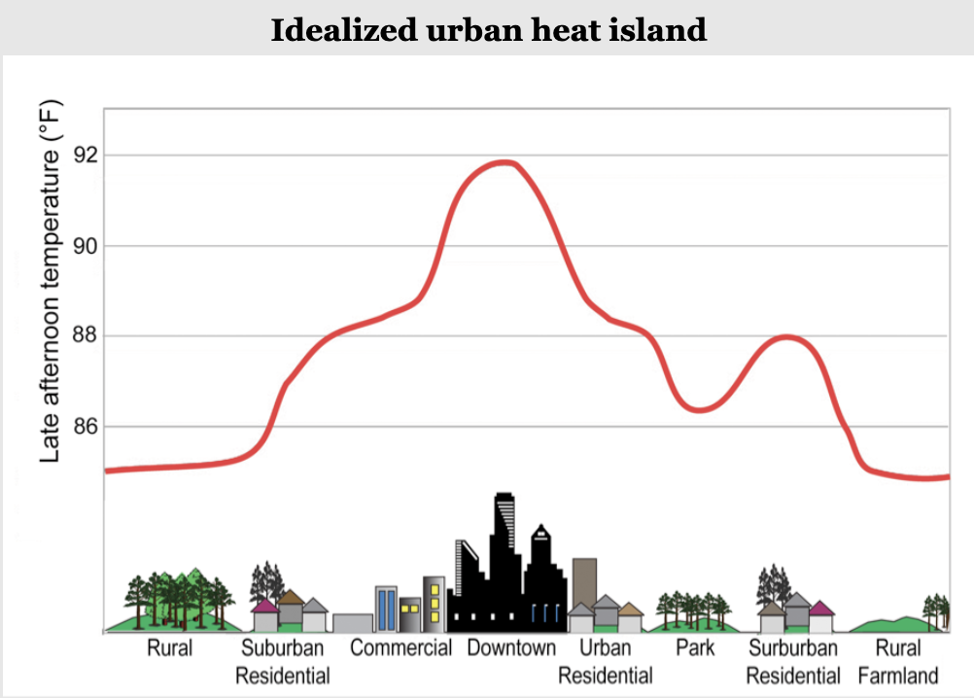

Figure1: **Idealized urban heat island** Lemmen, D.S. and F.J. Warren (eds.), 2004: Climate Change Impacts and Adaptation: A Canadian Perspective. Climate Change Impacts and Adaptation Program, Natural Resources Canada, Ottawa, ON, 174 pp.

**2.2 Identification of Gaps in Existing Research**

In recent years, numerous scholars have explored vegetation information and the interrelationships between vegetation and the thermal environment. These studies broadly fall into two categories:

1. Macroscopic studies: Some scholars have focused on large-scale relationships between urban greening and the thermal environment. For example, a study conducted in Beijing, China, analyzed this macroscopic relationship, and another study investigated the influence of distance anisotropy of the urban heat environment on heat islands from the perspective of spatial patterns. Most studies in this category involve qualitative work.(Yueyao Wang 2022)

2. Microscopic studies: Other scholars have concentrated on constructing thermal environment simulation models for urban greening research and have examined the effects of urban green landscapes from a more microscopic perspective. The presence of heat islands and the effect of green spaces on heat islands have been explored using the Uracil boundary climate model. More recent research on this front has applied cutting-edge technologies to extract different vegetation types at the roadside scale using street view images. The effects of different roadside vegetation types on land surface temperatures (LSTs) were explored based on geographically weighted regression (GWR). The results indicate that different types of vegetation have varied cooling effects in different spaces, with the areas exhibiting significant cooling effects being primarily located in the densely populated core areas with severe heat island effects.(Bin Li 2022)

Despite extensive research on the Urban Heat Island (UHI) phenomenon, gaps persist. Primarily, while numerous studies have focused on the broad relationships between urban land cover types and thermal environment, the specific interplay between different architectural and land-use designs within city blocks and their impacts on local thermal conditions are not comprehensively understood.

Additionally, many studies have primarily focused on general city-wide UHI effects, often overlooking the variability within individual city blocks. For instance, the UHI effect within the city blocks of Westminster, London, a city with a diverse array of architectural designs and land-use types, remains understudied. This leaves a knowledge gap as the unique attributes of such city blocks, which are often characterized by a rich interplay of green spaces, residential, and commercial buildings, may affect the UHI phenomenon differently.

These gaps limit our understanding of localized thermal environments and have practical implications for urban design and planning. Without an in-depth understanding of how architectural and land-use designs within city blocks contribute to the UHI effect, urban planners may lack the necessary information to design thermal-comfort optimized spaces.

**2.3 Justification for Study**

This research aims to bridge these gaps by investigating the relationship between different architectural designs and land-use types within the city blocks of Westminster, London, and the local thermal environment. Through this, it seeks to provide insights that could guide urban planning strategies in creating thermally comfortable urban spaces, thus contributing to the body of knowledge on UHI in unique, diverse city blocks like those found in Westminster, London.

**2.4 Conceptual Framework**

Key Variables:

Urban thermal environment, Semantic Segmentation of Street View, Multiple Regression, Data Visualization, Spatial Analysis

The conceptual framework for this study focuses on the direct effects of different types of land cover on the urban thermal environment. 11 types of land cover are considered: buildings, sky, tree, grass, water, river, road, ground, plant, car, land. These are the independent variables in this study. The urban thermal environment, the dependent variable, is influenced by these independent variables.

The literature suggests that each type of land cover has a unique effect on the urban thermal environment due to their specific thermal properties. Buildings and roads, often made from materials with high heat capacity, tend to store and emit heat, potentially increasing local temperatures. On the other hand, vegetation and bodies of water are known to have cooling effects due to processes like shading, evapotranspiration, and water's high heat capacity. The relationship between these variables is likely complex and multi-dimensional, involving other potential factors such as the spatial arrangement of land cover types. This complexity will be explored using street view semantic segmentation and multiple regression analysis. This research will further elucidate these relationships, contributing to the understanding of the UHI effect within the city blocks of Westminster, London.

Chapter 3: Methodology

In the present study, the specific geographical area of interest was delineated through the application of OpenStreetMap (OSM). Utilizing Rhino, a computational design tool, key points were systematically selected to facilitate the acquisition of street-level photographs. These points were strategically spaced at intervals of 10 meters to ensure comprehensive coverage and consistent data collection across the selected region.

A customized web crawling script, developed in the Python programming language, was employed to automate the process of image retrieval. This method yielded a total of 15931 photos, thereby providing a substantial dataset for subsequent analysis.

The primary analytical task was the semantic segmentation of these images. This was conducted using an image recognition algorithm implemented in Python. This technique facilitated the categorization and quantification of an array of environmental and urban elements present within the GSV images, with the algorithm capable of discerning up to 150 unique objects and calculating their relative proportions.

Following this initial broad-scope analysis, the study directed its attention to eleven key environmental and urban indicators: buildings, sky, tree, grass, water, river, road, ground, plant, car, and land. The selection of these indicators was informed by a comprehensive review of existing literature on Urban Heat Island (UHI) phenomena, acknowledging their potential role in influencing the intensity and spatial distribution of UHIs.

The semantic data extracted from the GSV images was subsequently analyzed in conjunction with Urban Heat Island (UHI) effect data, represented by average Land Surface Temperature (avgLST). The initial phase of exploratory data analysis (EDA) involved calculating the mean proportions of each of the eleven key indicators for each distinct urban block and determining the correlations between these mean proportions and the avgLST.

To expand on these preliminary findings, a multivariate regression model was implemented. This approach facilitated a more sophisticated investigation into the combined and individual impacts of the chosen environmental variables on the UHI effect, enabling the identification of the most influential predictors.

A parallel line of inquiry also considered the possible influence of different land-use categories on the UHI effect. This categorical analysis was conducted by incorporating the land-use data, suitably one-hot encoded, into the multivariate regression model.

The entire research methodology, encompassing all stages from data acquisition to final analysis, was executed in Python, exploiting libraries such as pandas for data manipulation, matplotlib for data visualization, and stats models for statistical modelling.

This integrative methodology facilitated a nuanced and comprehensive understanding of the complex interactions between various urban and environmental conditions, as depicted in the GSV images, and their influence on the Urban Heat Island effect.

Chapter 4: Results and Discussion

**4.1 Presentation of Data**

4.1.1 Scope of research

This study focuses on the analysis of ambient heat in London over a five-year period, from 2016 to 2020. The data provides the mean heat values, using a city block as the fundamental unit of analysis.

The study area is geographically demarcated by longitudinal coordinates that vary from -0.1520 to -0.1196, and latitudinal coordinates ranging from 51.5053 to 51.4920. The precise selection of these boundaries has facilitated a focused analysis of the spatial variability of urban heat within a representative and significant section of London's urban fabric.

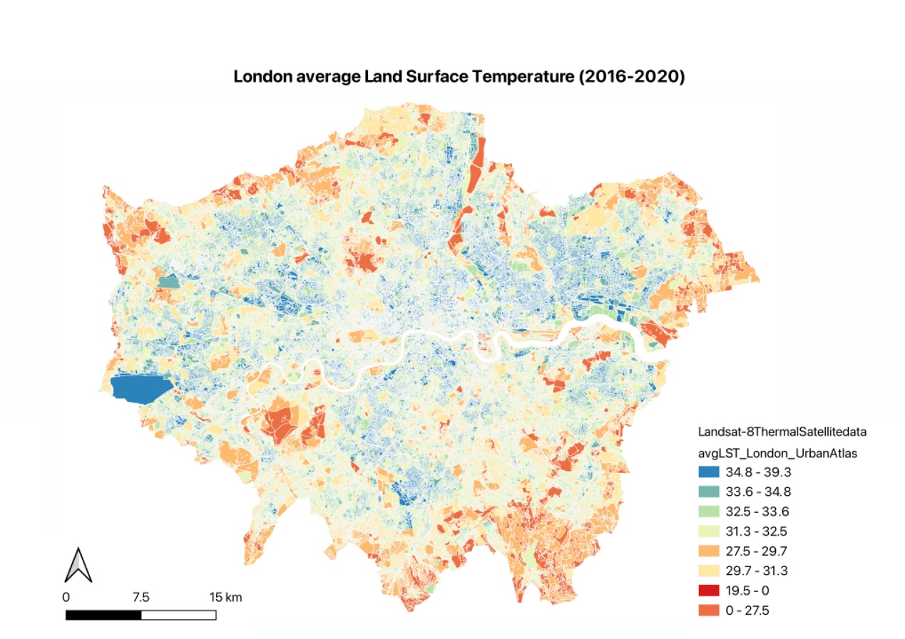

Figure1

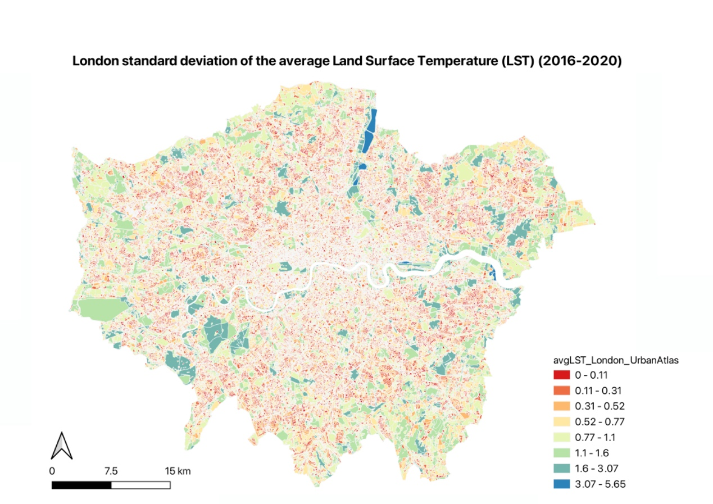

Figure2

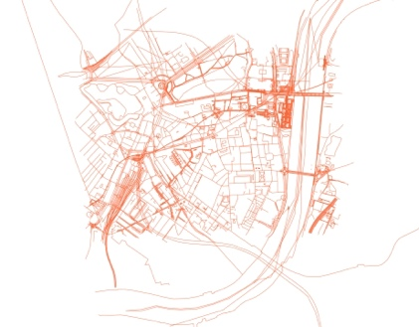 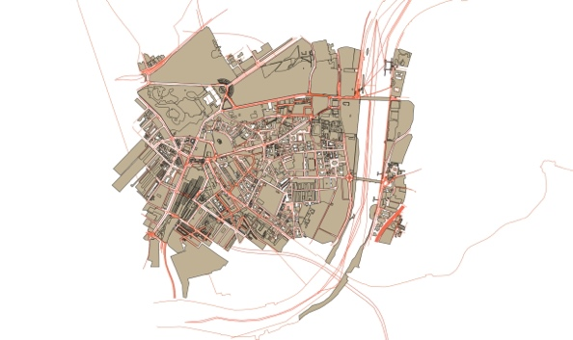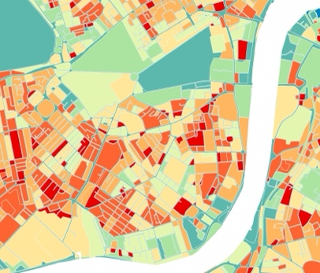

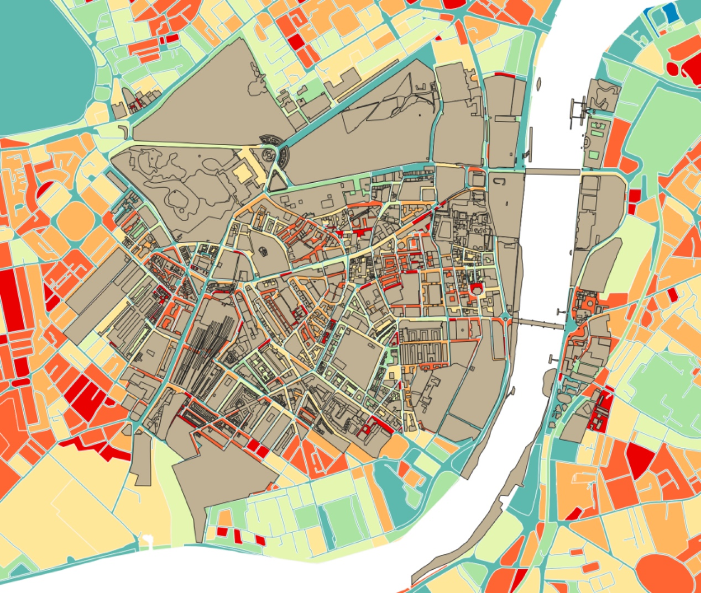

Figure3

4.1.2 Get Street View

A total of 15,931 high-resolution panoramic street maps were meticulously constructed for the designated study area by harnessing the capabilities of both the Grasshopper and Python programming languages. This methodical process of mapping comprised the periodic capture of geospatial information at consistent intervals of 10 meters. The focal temporal context of the gathered data primarily orbits the year 2018.

However, instances where the precise data for 2018 is absent were not overlooked. To address this shortfall, an automated fallback mechanism was instituted. This mechanism functions by intelligently sourcing the closest available data from the most recent temporal frame, thereby ensuring the continuity and comprehensive nature of the dataset. This amalgamation of high-resolution mapping and intelligent data retrieval ensures an exhaustive spatial representation of the study area within the stipulated temporal context.

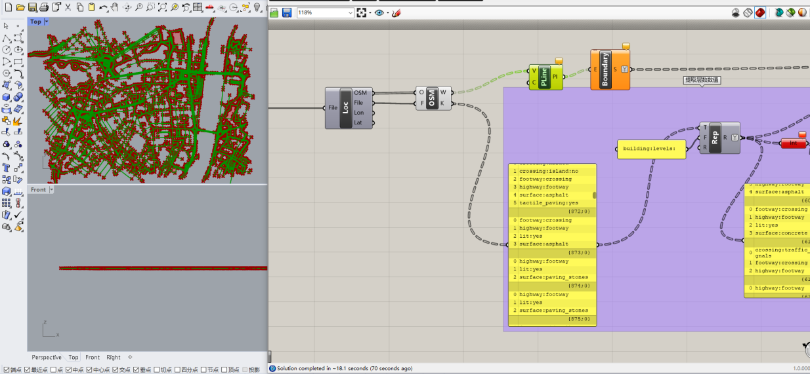

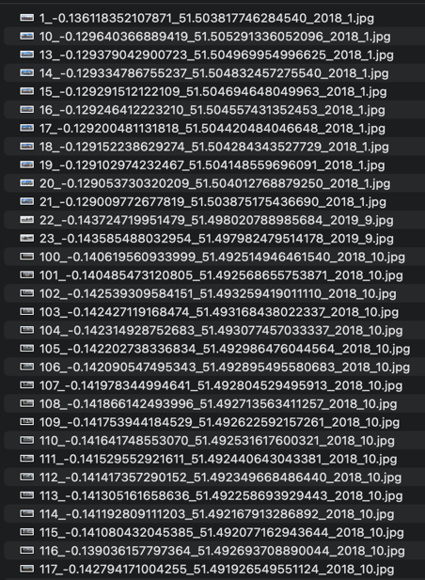 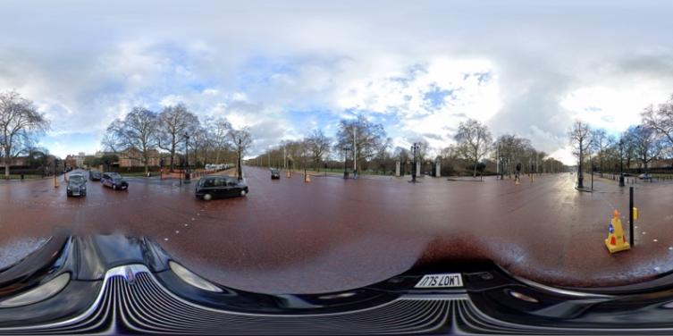

Initially, the two-dimensional boundaries of the study area, extracted from OpenStreetMap (OSM), were ingested into the Rhino environment. Grasshopper's capabilities were then leveraged to generate a spatially regular, grid-like distribution of points across the area of interest. This was performed via Grasshopper's "Rectangle" and "Divide Domain²" functionalities, which facilitated the creation of an overlaying mesh within the delineated boundaries. By adjusting the parameters of the grid, a specific point separation of 10 meters was achieved. The coordinates of these points were subsequently extracted, serving as the locational parameters for the forthcoming retrieval of Street View images.

Following the establishment of the grid points, Python was utilized to automate the extraction of the corresponding Street View images. This was accomplished by structuring API calls to Google's Street View API, where the URL for each image request was formed by substituting the precise coordinates of each individual grid point. This API request was submitted using Python's requests library, through a HTTP GET request to the designated API endpoint.

Upon successful retrieval of the image data, the Python Imaging Library (PIL) was then deployed to open and store the image data into the local system, iterating this operation across all grid points. It should be noted that Google's Street View API may not always provide images for every requested location at a specified time. In such instances, this limitation was accommodated by substituting missing images with those taken at the most recent available year.

4.1.3 Semantic analysis

A semantic analysis was meticulously executed employing Python to scrutinize the panoramic imagery procured from the street view dataset. The ensuing outcomes of this investigative process were meticulously documented in an exhaustive file, designated as “allresultfeature.csv” (hereafter referred to as File6). This file encompasses an array of 150 unique values, each of which denotes a distinct semantic feature discernible within the images.

These captured features constitute a diverse spectrum of visual elements observable within the urban milieu. While they are varied and numerous, notable examples encompass sky, trees, roads, grass, among an array of other visually significant attributes. This broad characterization affords a thorough representation of the environmental and aesthetic elements present within the dataset’s imagery, ensuring a comprehensive semantic overview.

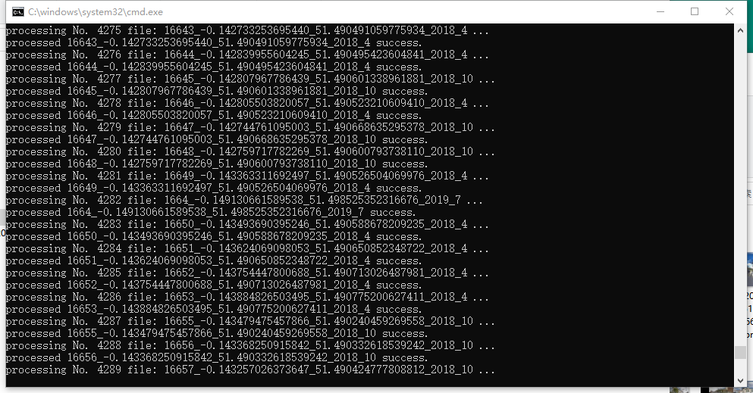

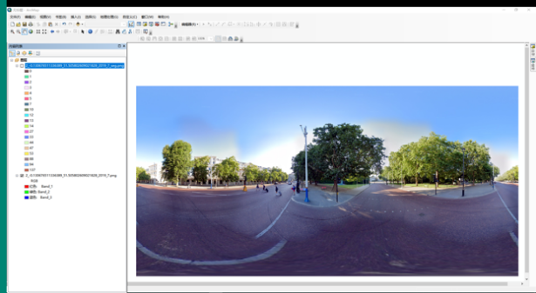 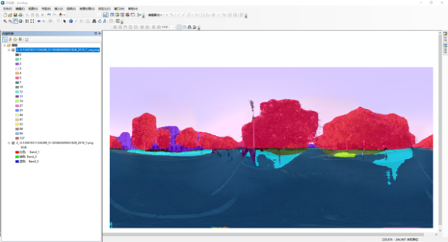

Upon the completion of image segmentation using Street View Semantic Segmentation, each pixel within the image is systematically allocated a label, signifying the object to which it is associated. Given the assumption that the segmentation output is an image in which the pixel values are synonymous with object categories, the image is initially transformed into a NumPy array.

The segmented image is loaded via a specialized library such as OpenCV, producing a two-dimensional array. In this array, each constituent element corresponds to a pixel, and the value of the respective element aligns with the class of that pixel. Subsequently, the frequency of each unique value within the array is computed.

By dividing the count of each distinct class by the cumulative total of pixels, the proportion of the image each class occupies is determined. Utilizing this data, a pandas Data Frame is constructed. In this Data Frame, the index aligns with the class, while the columns embody the percentage of pixels affiliated with the corresponding class.

Lastly, the Data Frame is stored as a CSV file (file6), thus yielding the sought-after output file. This comprehensive process embodies an effective method to analyze and categorize the different elements within a given image, granting valuable insights and enabling further exploration.

4.1.4 Collating data sets

The spatial datasets presented in File2 and File6 exhibit significant disparities in their respective coordinate structures. File2, which embodies a thermal environmental dataset, corresponds to the geometric configurations of city blocks, while File6, encapsulating a street view semantic analysis, is founded upon point coordinate data. This distinction necessitates the alignment of point coordinates with specific geometric forms, a process accomplished through the application of spatial linkage techniques.

Moreover, the substantial number of values, approximately 150, collated from File6 presents a challenge due to their extensive quantity. To ameliorate this, I conducted a comprehensive review of existing literature and ascertained eleven values of paramount significance for our study. These essential attributes include buildings, sky, trees, grass, water, rivers, roads, ground, plants, cars, and land. Consequently, these extracted components should enhance the precision and practical relevance of our analysis.

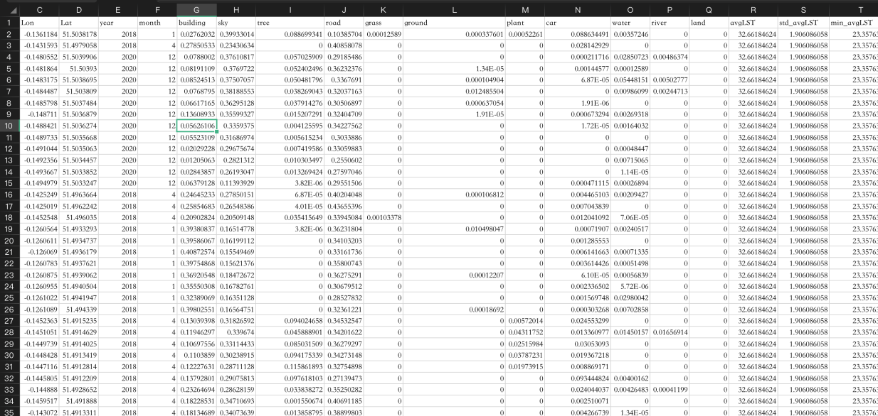

4.1.5 Spatial analysis

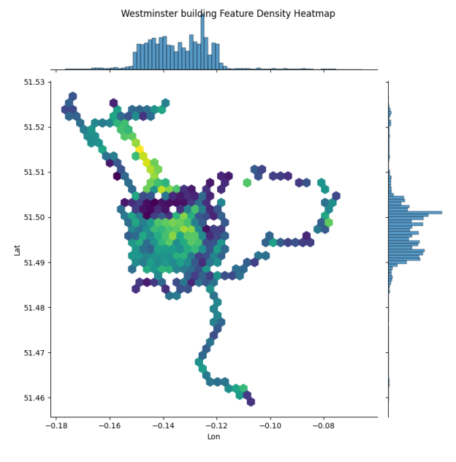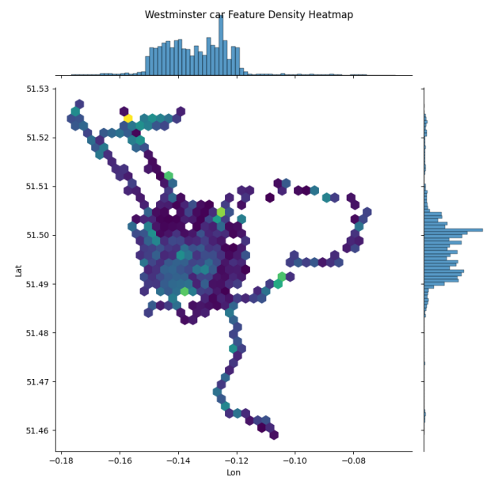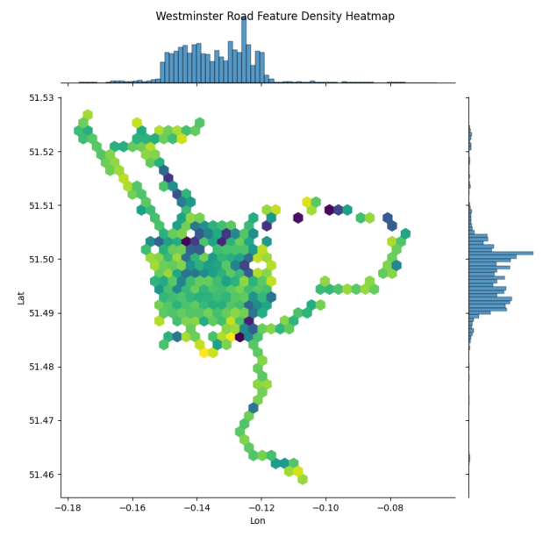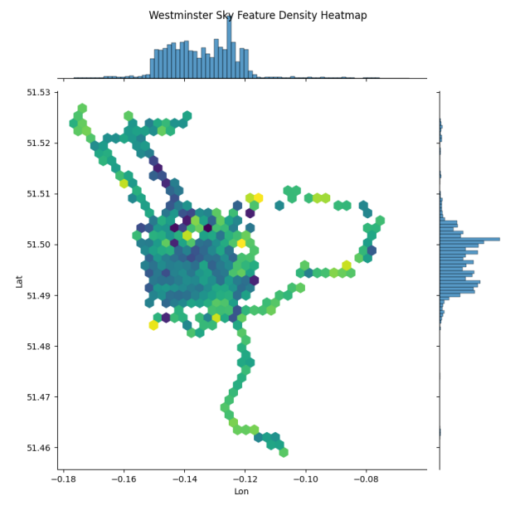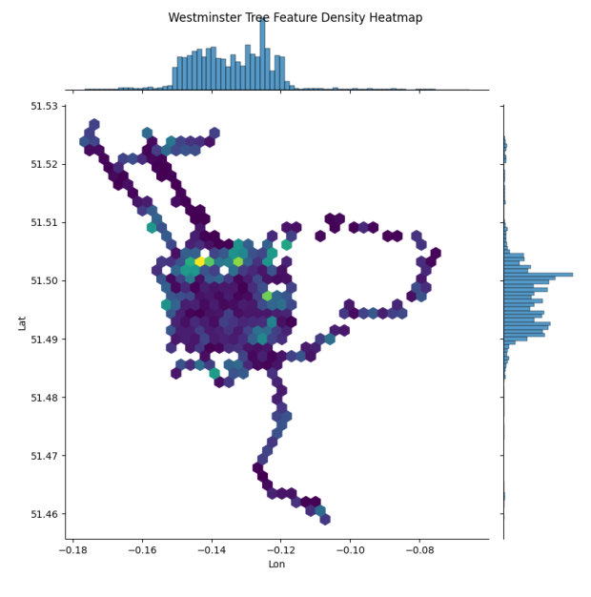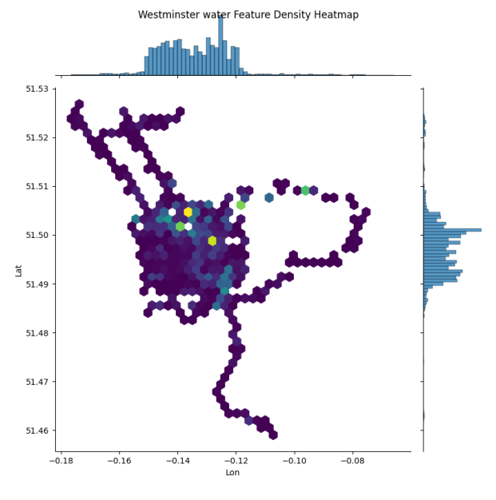

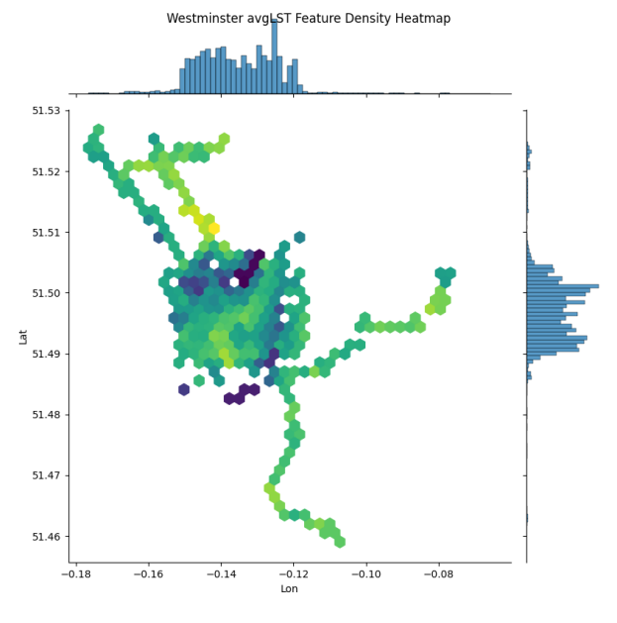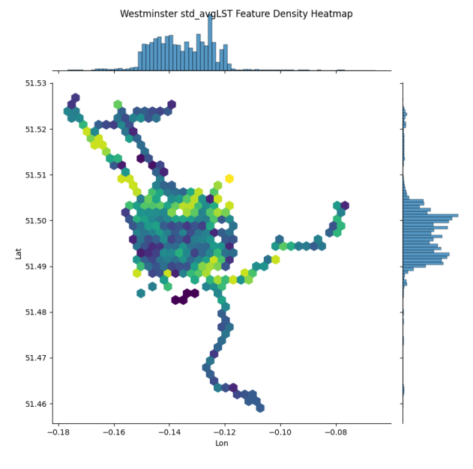

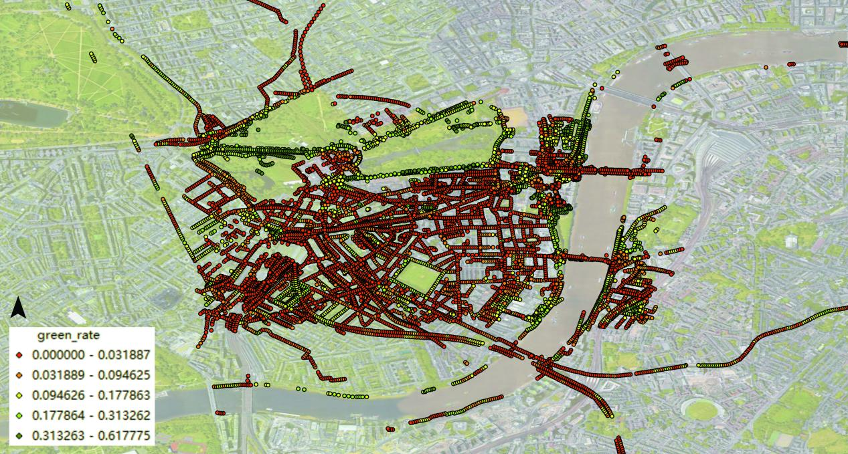

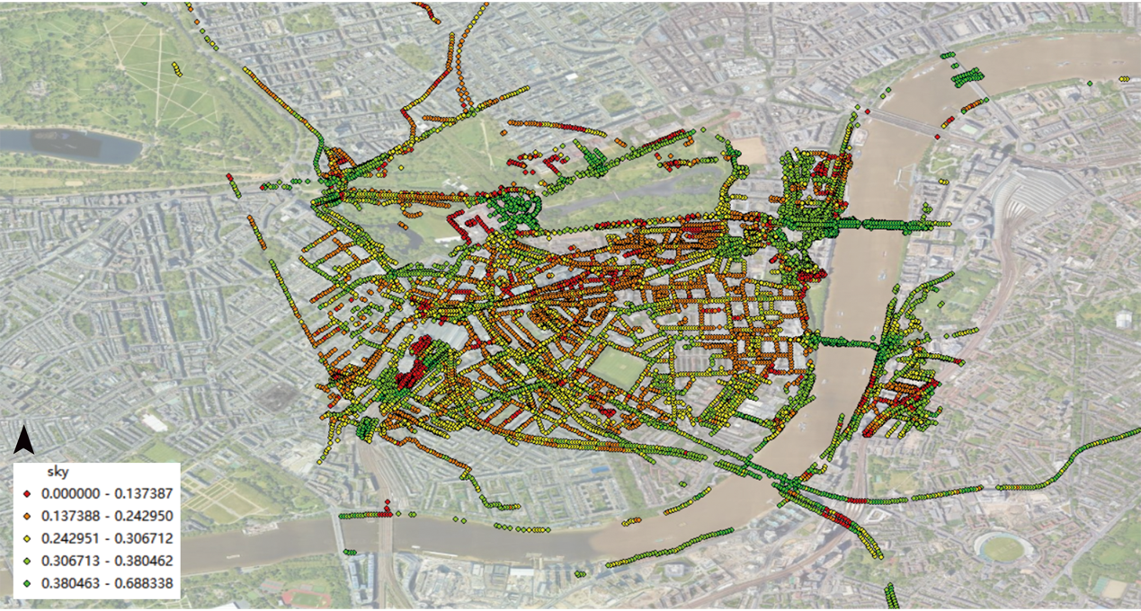

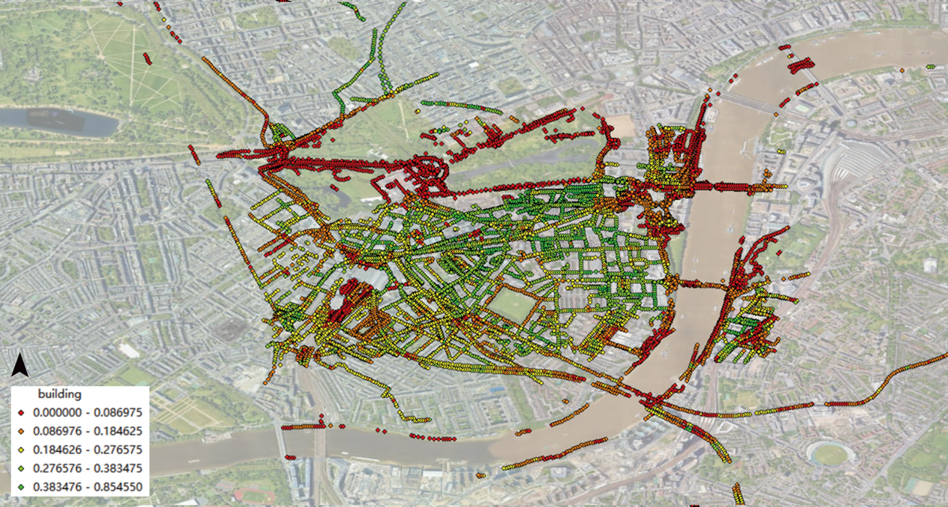

**4.2 Analysis of Data**

**4.2.1 Regression analysis**

Combine and clean the data

Since the first dataset contains latitude and longitude coordinates and the second dataset relates to urban areas, spatial connectivity based on geographical coordinates can be considered. The first step is too georeferenced the two datasets: the first dataset represents points (longitude and latitude) and the second dataset represents polygons (urban areas), which need to be converted into appropriate geometric objects. The second step performs spatial joining, matching the points of the first dataset with the polygons of the second dataset.

Correlation heatmap

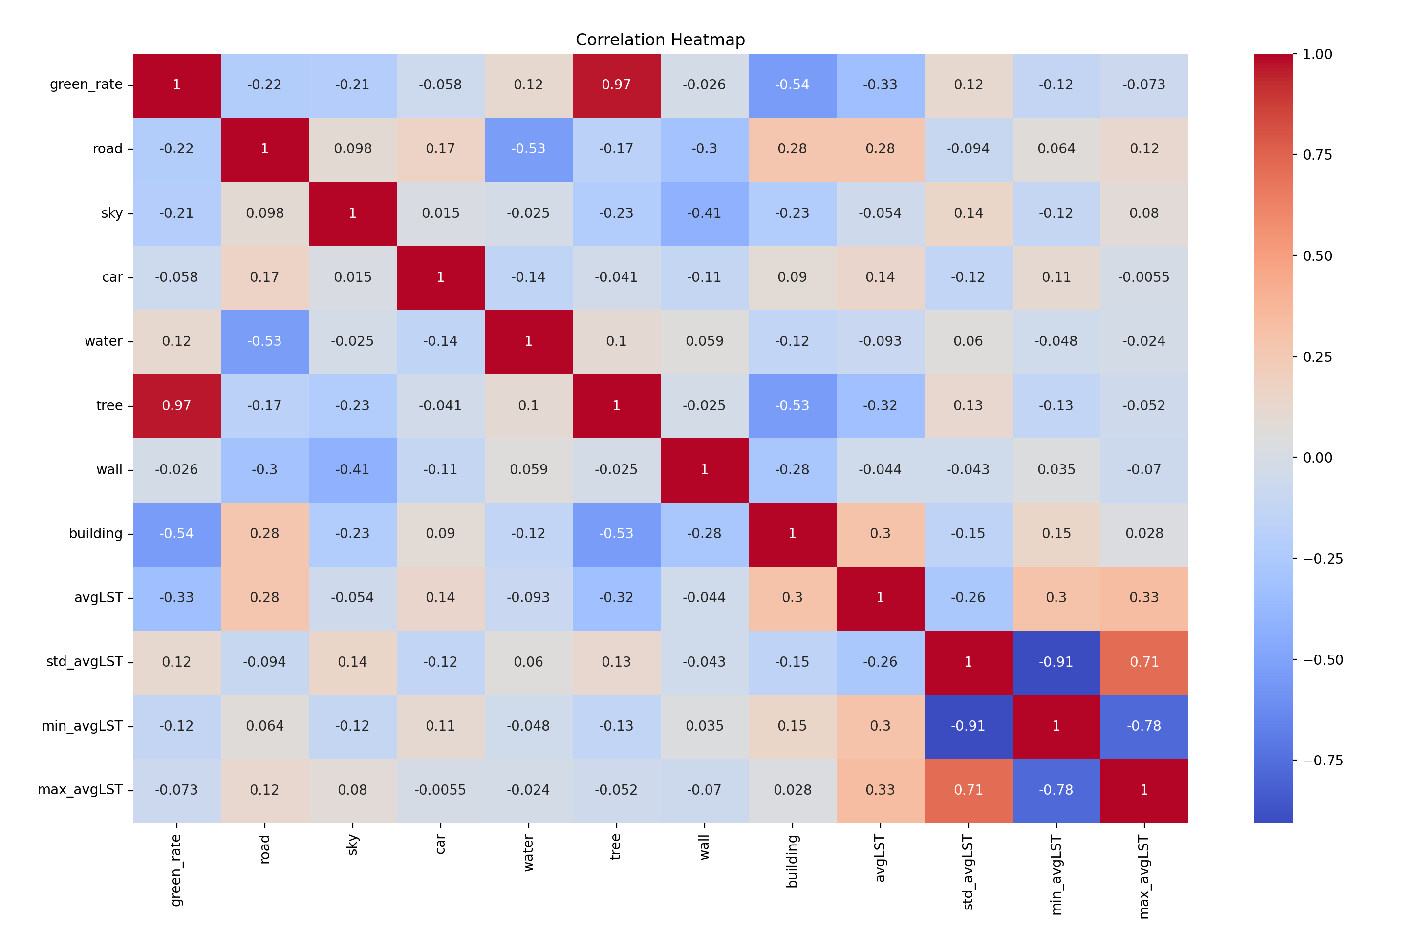

Stepwise regression

Stepwise regression is a method used to select the most significant variables for a statistical model from a larger set of potential variables. By excluding irrelevant variables, stepwise regression can help reduce multicollinearity, where independent variables are highly correlated with each other. By excluding irrelevant variables, it can help in avoiding overfitting,

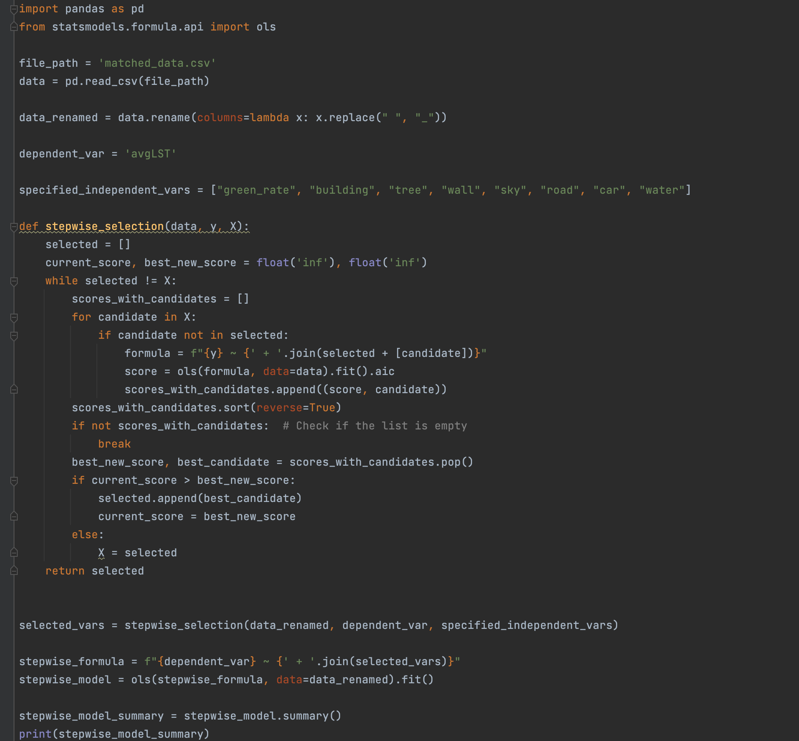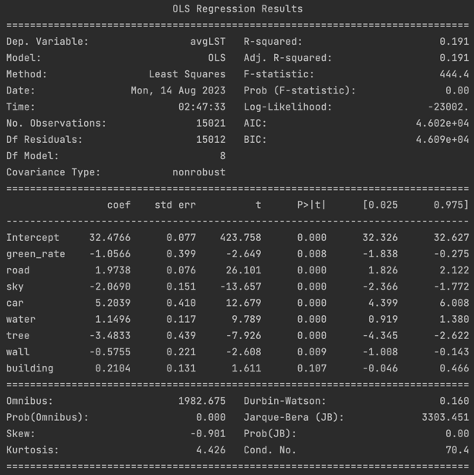

green rate: Coefficient = -1.0566 (p-value < 0.01)

A one-unit increase in green rate decreases avgLST by approximately 1.0566 units.

road: Coefficient = 1.9738 (p-value < 0.001)

A one-unit increase in road proportion increases avgLST by approximately 1.9738 units.

sky: Coefficient = -2.0690 (p-value < 0.001)

A one-unit increase in sky visibility decreases avgLST by approximately 2.0690 units.

car: Coefficient = 5.2039 (p-value < 0.001)

A one-unit increase in car proportion increases avgLST by approximately 5.2039 units.

water: Coefficient = 1.1496 (p-value < 0.001)

A one-unit increase in water proportion increases avgLST by approximately 1.1496 units.

tree: Coefficient = -3.4833 (p-value < 0.001)

A one-unit increase in tree proportion decreases avgLST by approximately 3.4833 units.

wall: Coefficient = -0.5755 (p-value < 0.01)

A one-unit increase in wall proportion decreases avgLST by approximately 0.5755 units.

building: Coefficient = 0.2104 (p-value = 0.107)

The effect of building proportion on avgLST is not statistically significant at the 0.05 level.

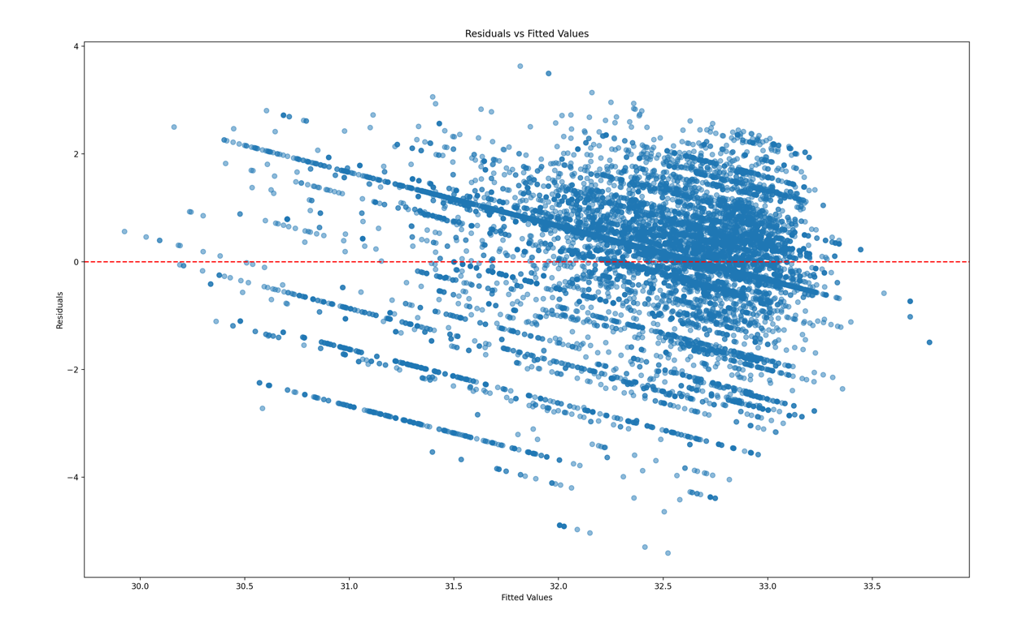

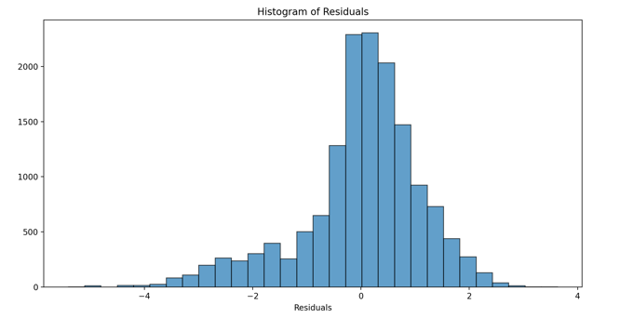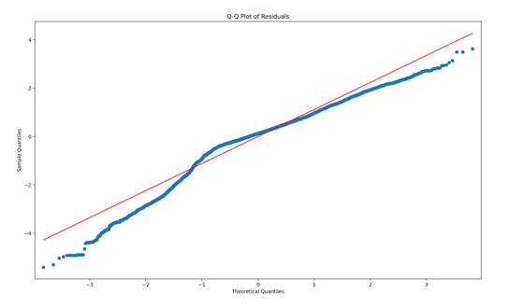

Viftest

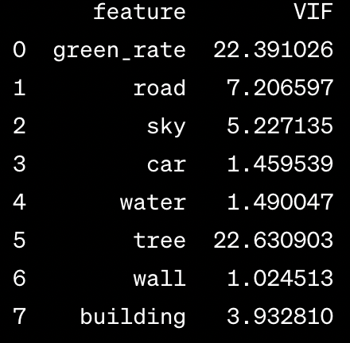

"green_rate" and "tree" have VIF values above 20, indicating strong multicollinearity with other independent variables. "road" and "sky" also show moderate to high multicollinearity with VIF values above 5. The remaining variables have VIF values below 5, indicating acceptable levels of multicollinearity.

**4.3 Interpretation of Findings**

Chapter 5: Conclusion

**5.1 Summary of Findings**

**5.2 Relationship to Existing Literature**

**5.3 Implications**

**5.4 Recommendations for Future Research**

**5.5 limitation**

Bibliography

2006. *Heat | London City Hall* [Online].  
Tilgængelig fra: https://www.london.gov.uk/programmes-and-strategies/environment-and-climate-change/climate-change/climate-adaptation/heat [Lokaliseret 13-08-2023].

Berardi, U., Jandaghian, Z. & Graham, J., 2020. Effects of greenery enhancements for the resilience to heat waves: A comparison of analysis performed through mesoscale (WRF) and microscale (Envi-met) modeling, *Science of The Total Environment*, årg. 747, s. 141300.

Bin Li, 2022. *IJERPH | Free Full-Text | Exploring the Effects of Roadside Vegetation on the Urban Thermal Environment Using Street View Images* [Online].  
Tilgængelig fra: https://www.mdpi.com/1660-4601/19/3/1272 [Lokaliseret 20-06-2023].

Carrasco-Hernandez, R., Smedley, A.R.D. & Webb, A.R., 2015. Using urban canyon geometries obtained from Google Street View for atmospheric studies: Potential applications in the calculation of street level total shortwave irradiances, *Energy and Buildings*, årg. 86, s. 340–348.

He, B.-J. et al., 2021. Localized synergies between heat waves and urban heat islands: Implications on human thermal comfort and urban heat management, *Environmental Research*, årg. 193, s. 110584.

Howard, L., 1833. THE CLIMATE OF LONDON.

Jusuf, S.K. & Hien, W.N., 2007. DEVELOPMENT OF EMPIRICAL MODELS FOR AN ESTATE LEVEL AIR TEMPERATURE PREDICTION IN SINGAPORE.

Rosenfeld, A.H. et al., 1995. Mitigation of urban heat islands: materials, utility programs, updates, *Energy and Buildings*, årg. 22, nr. 3, s. 255–265.

Taylor, J. et al., 2015. Mapping the effects of urban heat island, housing, and age on excess heat-related mortality in London, *Urban Climate*, årg. 14, s. 517–528.

Yang, F., Lau, S.S.Y. & Qian, F., 2010. Summertime heat island intensities in three high-rise housing quarters in inner-city Shanghai China: Building layout, density and greenery, *Building and Environment*, årg. 45, nr. 1, s. 115–134.

Yueyao Wang, 2022. *Atmosphere | Free Full-Text | Prediction of Urban Thermal Environment Based on Multi-Dimensional Nature and Urban Form Factors* [Online].  
Tilgængelig fra: https://www.mdpi.com/2073-4433/13/9/1493 [Lokaliseret 20-06-2023].

Zeng, L. et al., 2018. A fast approach for large-scale Sky View Factor estimation using street view images, *Building and Environment*, årg. 135, s. 74–84.

Data source:

<https://data.london.gov.uk/dataset/major-summer-heatspots-using-landsat-8-thermal-satellite-data>